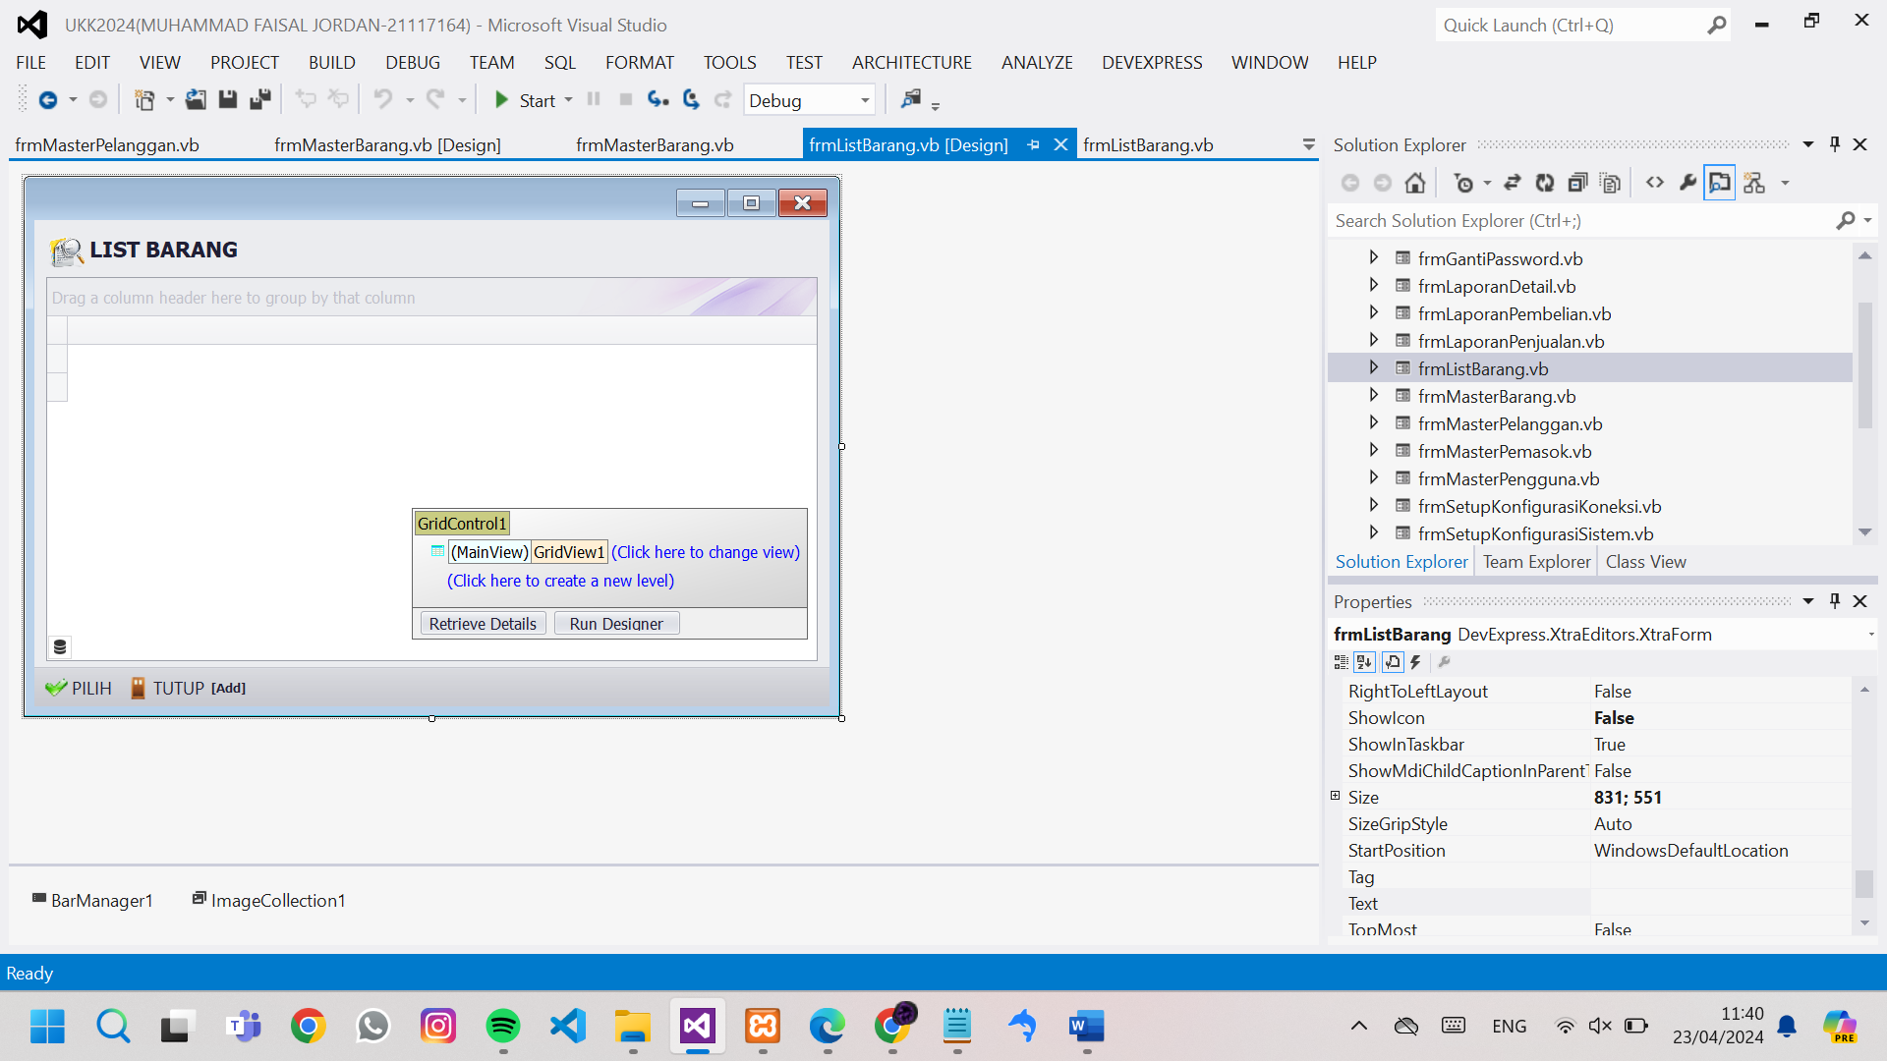

Public Class frmListBarang

Dim Tampung As New DataTable

Public NilaiKiriman As Integer

Sub TampilTable()

Tampung = EksekusiSQL("select * from barang")

GridControl1.DataSource = Tampung

GridView1.BestFitColumns() 'MERapikan tampilan isi kolom

End Sub

Sub Pilih()

Select Case NilaiKiriman

Case 1

'kembalikan data ke pembelian

frmTransaksiPembelian.txtCari.Text = GridView1.GetFocusedRowCellValue("ID_BARANG")

frmTransaksiPembelian.TambahItemBarang()

Me.Close()

Case 2

'kembalikan data ke penjualan

frmTransaksiPenjualan.txtCari.Text = GridView1.GetFocusedRowCellValue("ID_BARANG")

frmTransaksiPenjualan.TambahItemBarang()

Me.Close()

End Select

End Sub

Sub Tutup()

Me.Close()

End Sub

Private Sub frmListBarang_KeyDown(sender As Object, e As KeyEventArgs) Handles Me.KeyDown

Select Case e.KeyCode

Case e.Control And Keys.S

Pilih()

Case Keys.Escape

Tutup()

End Select

End Sub

Private Sub frmListBarang_Load(sender As Object, e As EventArgs) Handles MyBase.Load

Me.KeyPreview = True

EksekusiRapikanGridView(GridView1)

GridView1.FindFilterText = Nothing 'kosongin pencarian

TampilTable()

End Sub

Private Sub GridView1_DoubleClick(sender As Object, e As EventArgs) Handles GridView1.DoubleClick

Pilih()

End Sub

Private Sub BarButtonItem2_ItemClick(sender As Object, e As DevExpress.XtraBars.ItemClickEventArgs) Handles BarButtonItem2.ItemClick

Pilih()

End Sub

Private Sub BarButtonItem7_ItemClick(sender As Object, e As DevExpress.XtraBars.ItemClickEventArgs) Handles BarButtonItem7.ItemClick

Tutup()

End Sub

End Class